The following is a link to DIT’s instructions using the Cisco Self-Care Portal from outside of UMD network: https://umd.service-now.com/itsupport/pfeifer@umd.edu?id=kb_article_view&sys_kb_id=c001bfa61b6bc090ef518738cd4bcb99

Some of the instructions are a bit confusing, so we’ve included additional instruction below with screenshots.

From outside the UMD network, you need to connect to the UMD VPN on your laptop or desktop using the Cisco AnyConnect Secure Mobility Client. Select "vpn.umd.edu" for your connection option.

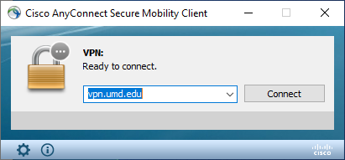

The VPN will prompt for your UMD credentials. Once connected to the VPN, navigate to Telephone Self Care portal at https://phone.umd.edu/ucmuser. The system will ask you for your UMD login credentials.
On the main screen select the “Phones” tab and “Call Forwarding” option.
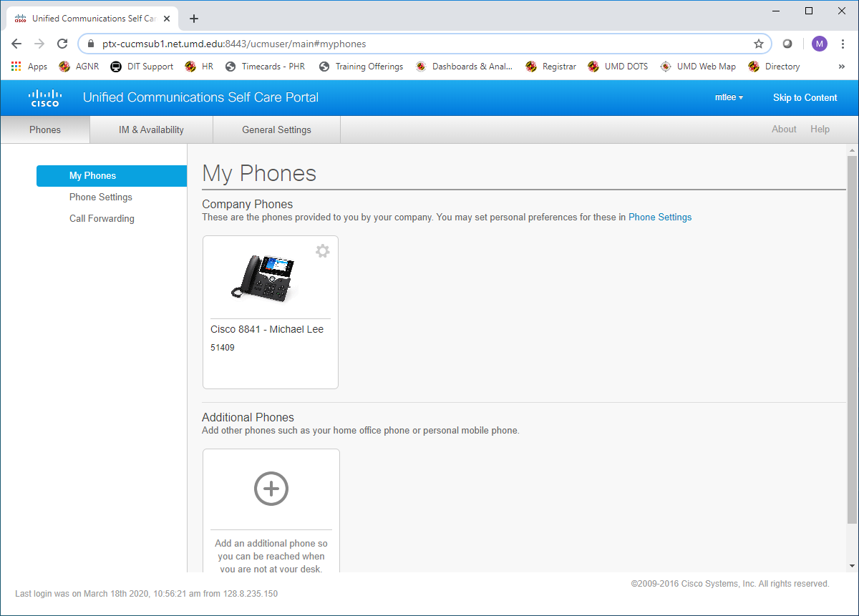

Once on the call forwarding page, place a checkmark next to “Forward all calls to” and type in the number that you want your calls forwarded. In order to forward them to an outside line you will need to include "9" for outside dialing (example: 92025551212). If the telephone number is out of the local calling area you will also need to include “1” to access long distance forwarding (i.e. – 917065551212). See the example below.

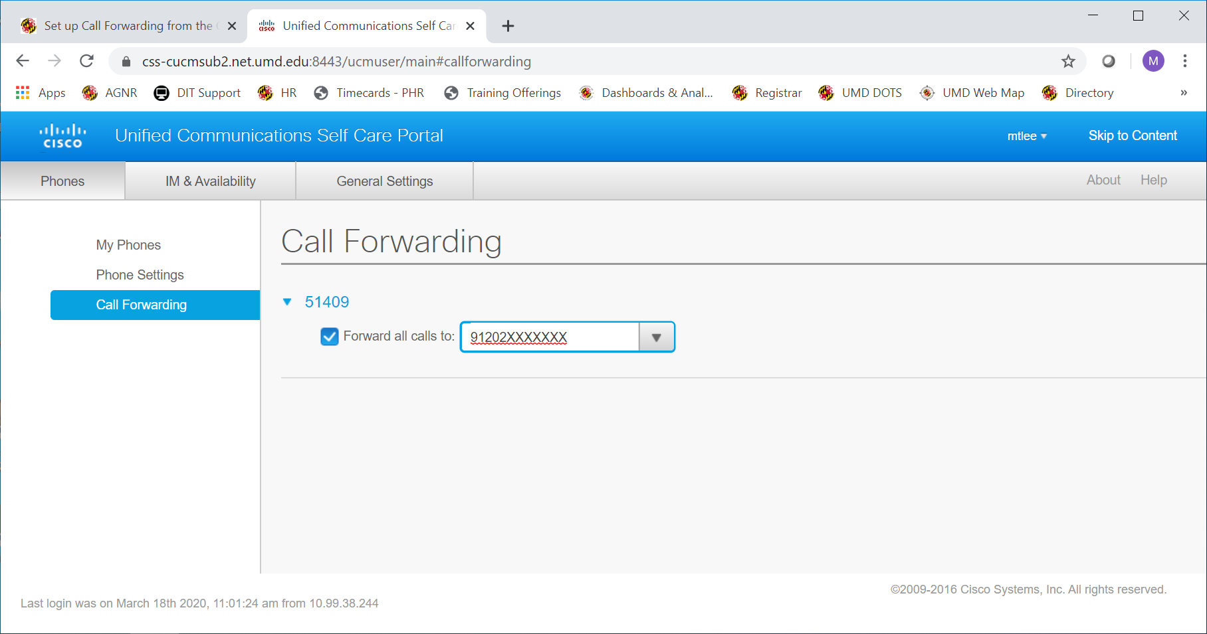
Click on the “save” button if it prompts your to do so.
If you are trying to forward your call from your phone while in the building, please following these instructions located at https://umd.service-now.com/itsupport/pfeifer@umd.edu?sys_kb_id=caf3be76db23c4504cb03562399619d6&id=kb_article_view&sysparm_rank=3&sysparm_tsqueryId=785a00dbdb67c0904cb0356239961961

Forward Calls
- To forward calls on your primary line to another number, press the Forward All softkey.
- Enter a phone number or press the Messages button to forward all calls to your voicemail.
- Look for confirmation of the forward on your phone display.
- To cancel call forwarding, press Forward Off.
NOTE: When setting up call forwarding you must add a 9 for a non-UMD line and a 1 for an area code that is not 301. Example: 91-202-123-3456.

